Scarlet Pimpernel aka Stark’s Earliest (?)

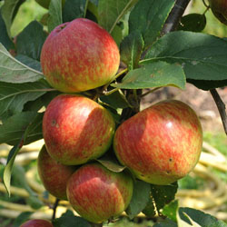
This is a vigorous, heavy cropping tree and we normally have to thin the fruit considerably over the summer. It produces fine apples which are smallish, have a refreshingly sharp taste and are very juicy. Our tree has found a niche for itself here in the corner and has an appealing wild look about it; the variety is said to need protection from the wind, and this seems to be a good spot for that. But although the Scarlet Pimpernel is our best guess, we can’t say for certain that’s what it is in this case.

Golden Noble

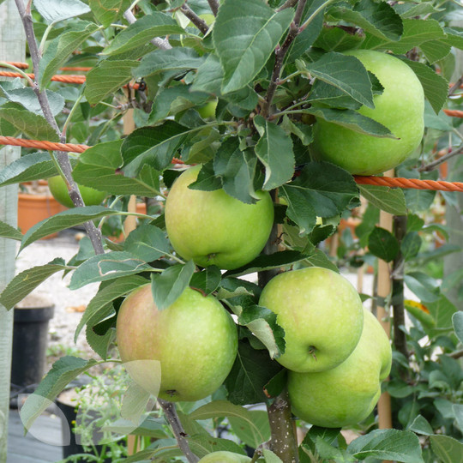
The Golden Noble has been grown in the UK since the early nineteenth century. It is a cooker, a little sweeter in flavour than many others and with a smooth, creamy texture after baking. The tree is known for its attractive pink flowers through the spring and the fruit, which can be eaten from October through to January, are green with a noticeable golden glow.

Court of Wick

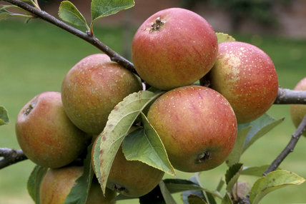
Producing a small fruit with red-to-golden colour and russet markings, our Court of Wick is one of our most reliable fruiters, giving us a strong crop every year, even in the face of a scab outbreak and some savage pruning! The apples have a strong, sharp, fruity flavour and can be used either as eaters or for cider-making.
Peasgood Nonsuch

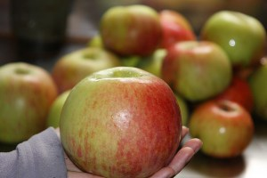
A tree bearing large apples with an attractive appearance which may be used for cooking or eating. The young fruit tend to have a large red patch that breaks up into stripes as it ripens, finally becoming an attractive, even red and yellow apple. The flesh is soft, slightly sharp and very succulent, becoming a light and sweet puree when cooked. An early fruiter, they can be picked in early September and are best used the same month.

Lord Derby

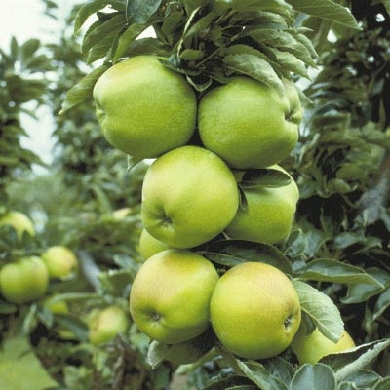
The Lord Derby is usually known as a cooker, although some of us have been known to use the fruit from this tree as eating apples too! The tree produces lavish crops of initially shiny green fruit that later bulge and become golden yellow, sometimes with russet patches. A very hardy tree, it is grown all over the UK and will withstand all the major diseases of top fruit as well as being able to tough it out through plenty of frost. If some of the fruit are picked in October the tree will continue cropping toward the end of the year.
D’Arcy Spice

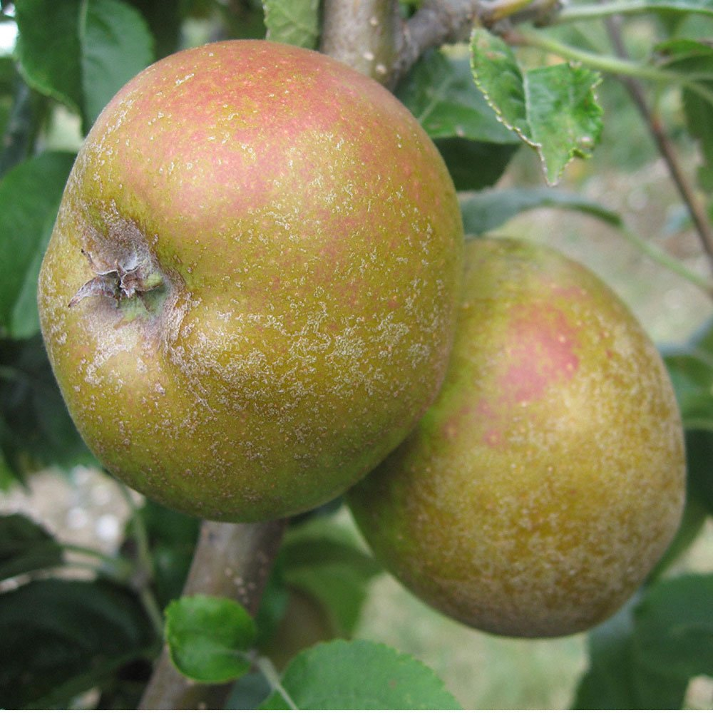
This tree is usually the last of our apples to be picked. The longer the fruit is left on the tree, the better the taste. Heavily russetted with a thick texture to the flesh, the D’Arcy Spice has an unusual aromatic flavour which – as you would expect – is quite spicy (some say reminiscent of nutmeg). One for the connoisseurs perhaps, and amongst the favourites of some of our orchard-goers. The other part of the name comes from its origin as a seedling developed at Tolleshunt D’Arcy Hall in Essex in the 1800s.
Pitmaston Pineapple

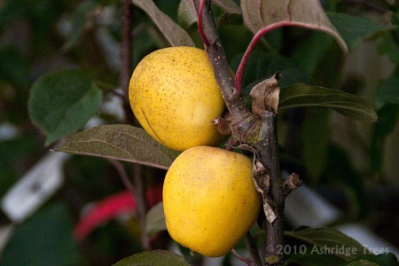
One of the loveliest apples you can eat in our humble opinion, the ‘Pineapple’ has a uniquely sweet and nutty flavour. The name refers to its appearance rather than taste; the lower end of the fruit tapers slightly and the bright yellow colour is reminiscent too. The apples are small but the tree fruits abundantly and is a healthy, scab-resistant breed. We cannot understand why it is not more frequently grown!

Tom Putt

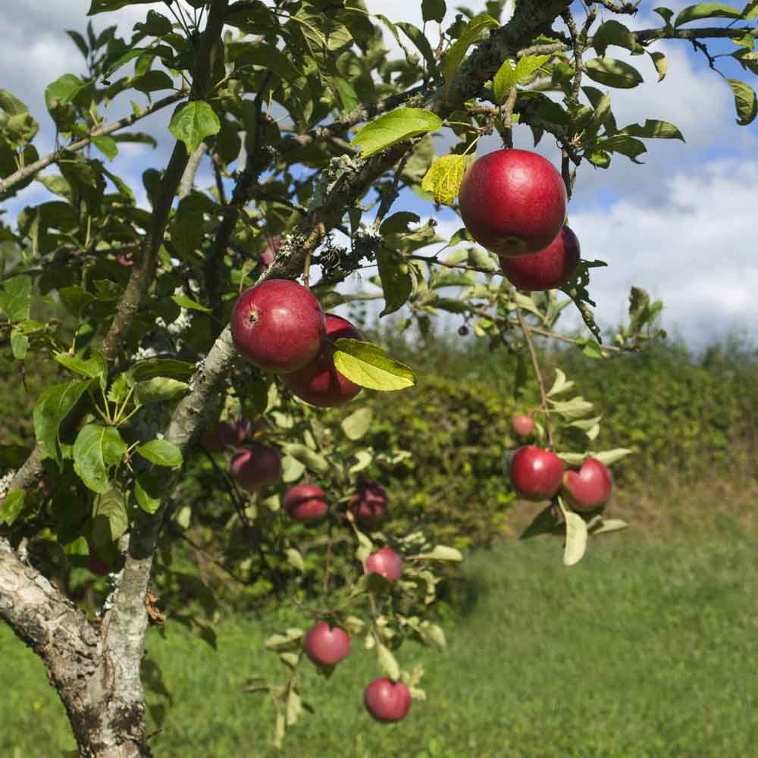
The large red apples produced by this tree are great all-rounders. Officially listed as a cooking apple, they are also delicious to eat, are a good cider apple and are excellent for juicing too. A Tom Putt tree is a real trooper; it is vigorous, begins cropping young and bears large, steady harvests year in, year out on branches that have a spreading habit. This tree has given us many excellent crops and, true to type, seems happy with what might be referred to as an eccentric shape (the result of many years without pruning)!
Adams Pearmain (?)

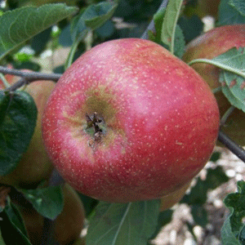
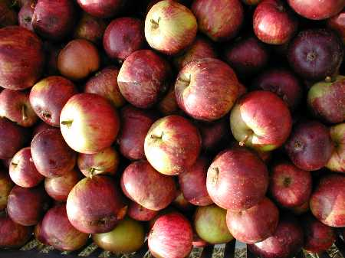
We must confess we’re not 100% sure about the variety of this tree. Our best guess is that it is an Adams Pearmain (left), a dessert apple with a crisp and juicy texture, which certainly fits the bill. But it’s possible it could instead be an example of a Frederick (right), which is often used for cider. Either way, its large reddish fruit are a welcome part of our harvest each autumn.
Early Victoria

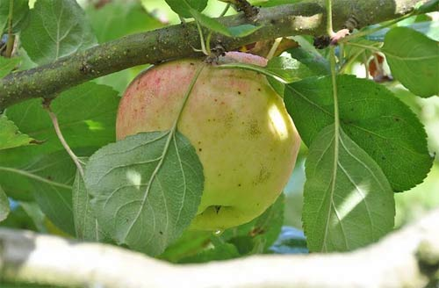
Early Victoria apples are a radiant light green during growth, turning a rustic pale yellow when ripe. The tree is described as a very reliable cropper – which is just as well as this particular tree has to struggle by in a less than ideal spot with little sunlight and the fruiting branches often becoming overcome with vegetation from below during the summer. Nevertheless it valiantly produces some apples for us each harvest.

